<https://blog.google/products/maps/google-maps-best-features-tips/>

Features of Meta Map to keep:

* Possibly more features from CAE feedback and the [website](https://blog.google/products/maps/google-maps-best-features-tips/):
  + Search bar or tapping on destination
    - **Spotlight one route** instead of having a cluttered view of all of the accessible routes to all destinations at once

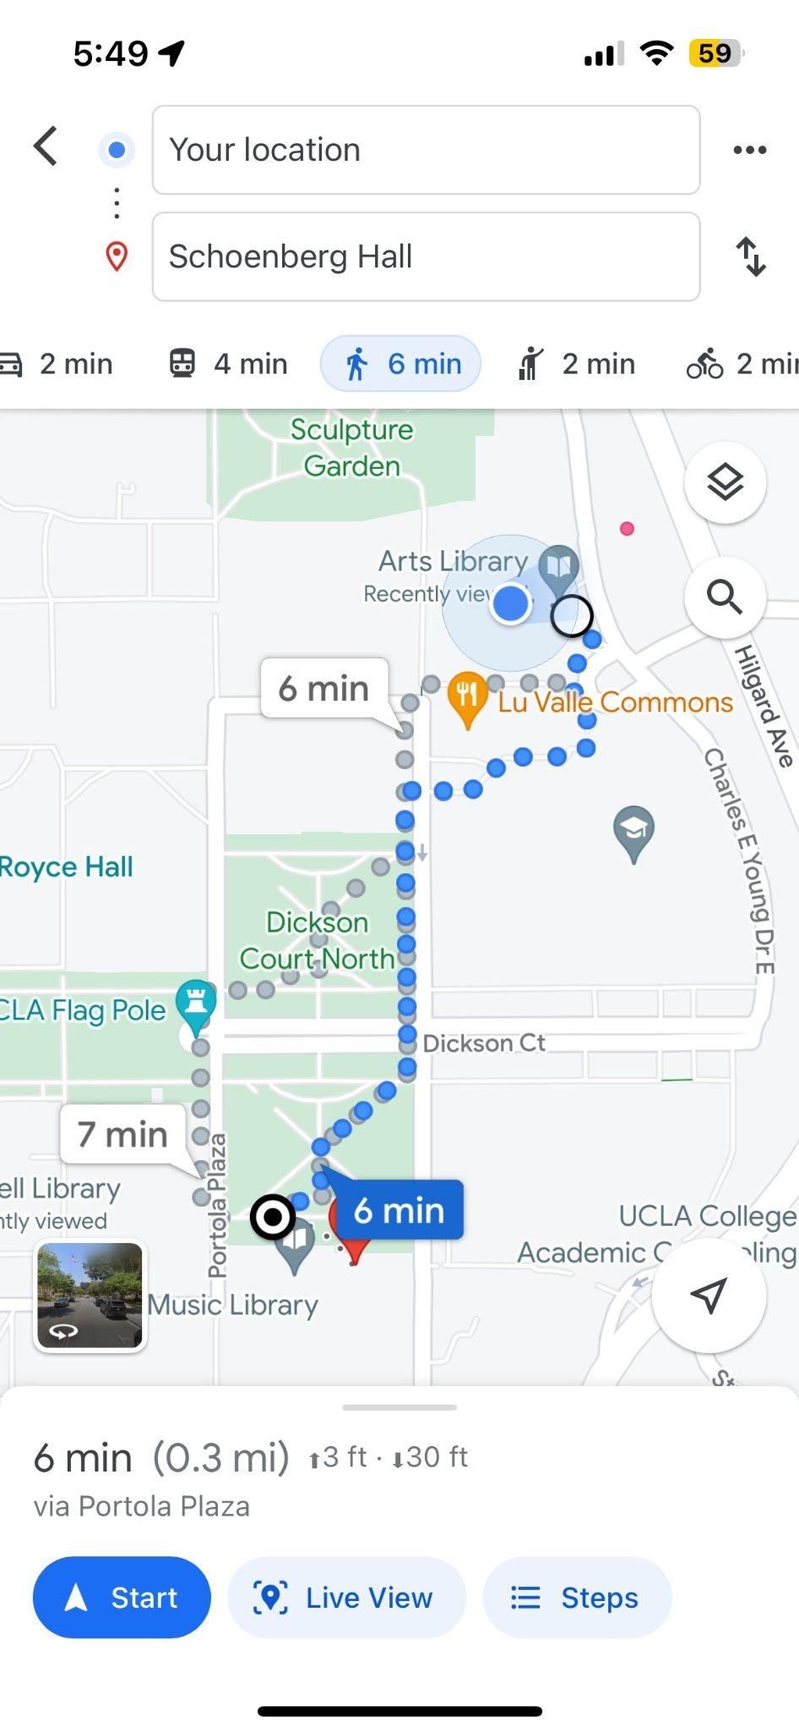 versus 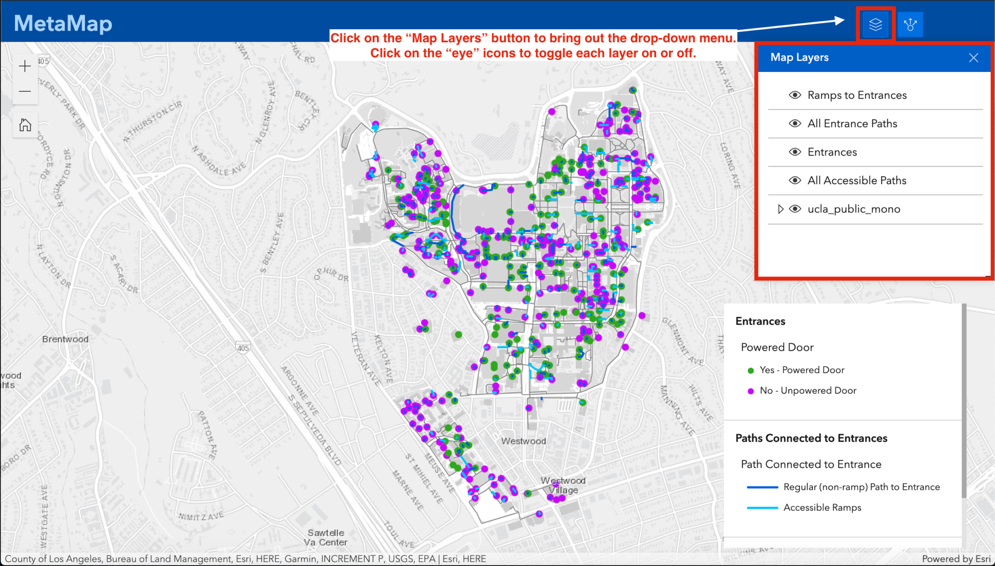

* + **Audio** narrations (for blind individuals)
  + Directions in **Virtual** **Reality**: for people who want to visualize the route with directions (more interactive and less physically draining to walk around):

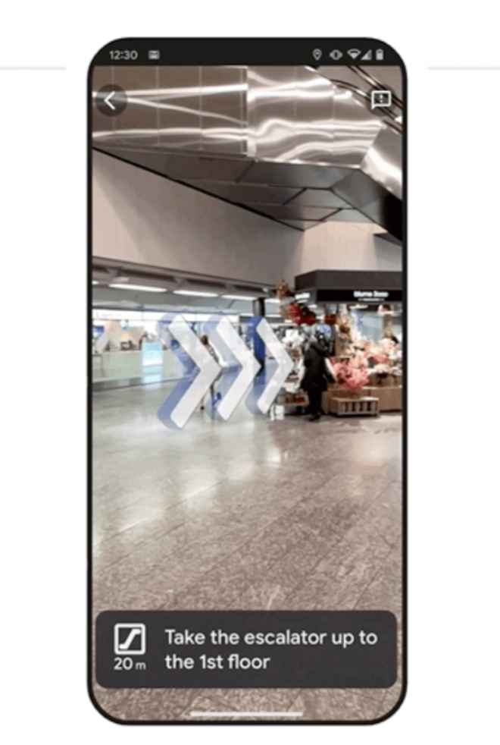

* Accessibility

For Low-Fi Wireframe:

For Prototype:

* + Color: Contrast ratios are laid out in the Web Content Accessibility Guidelines (WCAG)
  + Accessible Collor Pallette Gerator: <https://venngage.com/tools/accessible-color-palette-generator>

Well lit paths*

Feedback on paths

Feedback from 11/8

* Said our project has a strong concept
* Potential things we could add/ focus on
  + Text message feature to report broken elevators
    - Print stickers with QR codes and post them by elevators, if an elevator isn’t working the student can scan the code to report it
    - That could send out a text to others who have signed up for notifications, telling them that the elevator is broken
  + List of major routes that UCLA students commonly take
    - Identify and lay out accessible pathways that students can use to get to popular places on campus
    - Maybe like:
      * Dorms → court of sciences
      * Dorms → ackerman
      * Alternatives to going up Jans steps/ bruinwalk
      * Dorms → Royce/ Powell
    - And then show different accessible paths for each
    - For this project, it would probably be easier to do this than to build a fully functioning digital map w/ google maps features
* Keep iterating and working on it, decide what parts of the project we want to build out more and test with people
  + We can keep making prototypes for our map and google maps features, but idk I think it might be hard to build out a fully functioning digital version of the accessibility map, or figure out how to add google maps type features
  + Also might be hard to build out VR or AI functionality
  + Yeah, he basically said we can continue thinking out ideas but that we should focus more so on one aspect (i think?) He seemed interested in highlighting accessibility ramps rather than creating a map that also assists other disabilities, kept emphasizing feasability
* Could also print stickers and post them around campus to indicate where hidden ramps are?
  + Idk if this is really part of the project tho lol
    - I also didn’t know if this would be apart of the project but he proposed adding a qr code to link our map?
* We can maybe all build wireframes and work together to build full fledge concept without extra things, (add routes we know off etc)
  + He also suggested that the reporting elevators aspect wasn't feasible but I still enjoy that concept?
    - At times it sounded like he wanted us to focus on just building a text message system to report broken elevators rather than a map, or do that in addition to a map
* Home page- isha
* Login page-isha
* Show different routes page/maps - stella
* Connect with class schedule page- emma
* common routes/voice assisted page- emma
* Report page- Claudia
* Feedback on app page
* more routes page

Feedback from 11/13

* Reporting
  + Having reporting go out to people via text
    - Not everyone will have the app
    - But have reports go out to people via text so that more people can see the issue
  + Maybe be able to send reports to professors to explain why you’re late
  + Find a way to have some indicator on the map, since some elevators are almost always broken and staff usually knows about it
  + Maybe have two versions?
    - Students report
    - Staff confirms it, or indicates when it’s fixed (since first report might be a false alarm)
* How would we be able to implement the elevator/ power assisted door features on the map?
* Lay out routes in the buildings, since navigation in the buildings can be difficult (especially science buildings)
* Prof’s feedback
  + Looks nice and clear concept
  + We haven’t really touched on the information itself, like
  + Maybe develop the text reporting feature
  + Stickers?
* For next time
  + Come up with a couple specific routes